Online Supplementary Material

A phylostratigraphy approach to uncover the genomic history of major adaptations in metazoan lineages
Tomislav Domazet-Lošo¹, Josip Brajković¹ and Diethard Tautz²
¹Division of Molecular Biology, Ruđer Bošković Institute, Bijenička cesta 54, P.P. 180, 10002 Zagreb, Croatia
²Institute for Genetics, Zülpicher Straße 47, D-50674 Cologne, Germany
Corresponding author: Domazet-Lošo, T. (tdomazet@irb.hr).

Extended introduction
The phylostratigraphy approach rests on the assumption that at least a significant fraction of genes has retained its original function after its origination. However, the issue of gene origin is evidently not trivial. For example, when a new gene stably enters a genome [1–3], regardless of the mechanism of its creation [2], its degree of sequence similarity to the other genes can vary substantially. Often, sequence similarity will be easy to track via paralogous genes in the genome and thus the new gene will be regarded as a new member of some gene family. Specially interesting, however, are founder gene formation events, where the novel genes lack sequence similarity to the other genes in the genome. In our previous study on orphan gene evolution in Drosophila [2], we have proposed a model where newly arisen genes might initially show very high evolutionary rates, until they become locked into an important functional pathway of particular relevance for the new lineage. From this point onwards, their evolutionary rate will slow down and they will be recognizable in the descendants of this lineage. Thus, a founder gene formation represents a jump in the sequence universe, and we assume that a novelty brought by the founder gene could be considered, in a good number of cases, as an adaptive innovation. Moreover, recent work suggests that even ancient gene families evolved in a punctuated manner from the founder genes [4]. Therefore, we assume that the process of founder genes formation, that is observed in more recently evolved lineages, will have operated throughout the whole evolutionary history.
The next question is whether one can expect that extant genes carry an echo of the functional properties of their founder genes. A process that could blur this echo is neofunctionalization after gene duplication. Recent advances in understanding new gene formation and gene family evolution [2,5–8] shed some light on this issue. The majority of proposed scenarios that lead to the birth of the new genes include some sort of sequence duplication events, where duplicated copies could have several fates after duplication [5–8]. However, radical neofunctionalization that brings completely novel types of function after gene duplication seems to be a rare event. By contrast, subfunctionalization [5–7] and partial neofunctionalization [6] are frequent scenarios that only moderately erode the original sequence and functional information. Therefore, under the assumption that gene family evolution proceeds in a punctuated manner, the radical neofunctionalization events can be considered to be mainly connected to the process of formation of the founder genes.
Finally, as Table 1 (in the main article) shows, and as expected for such a large-scale analysis, there may be gaps in our knowledge base. For example, phylostratum 8 (Protostomia-Arthropoda) lists only 52 genes, which is almost 2 orders of magnitude lower than other nodes. It is of course important to note that the phylostrata represent different periods of time, similar as geologic epochs represent different time periods. As the number of genes in each phylostratum is to some extant correlated to the elapsed time periods, observed fluctuations have to be expected. Indeed, the molecular time estimates (Table S1) indicate that the time span for phylostratum 8 is rather short compared to the other phylostrata, i.e. the time for accumulation of the founder genes in this period was also limited. Hence, it is to be expected that the remaining signals from this period are more noisy.

Detailed description of methods

Phylogeny and similarity search
The phylogeny used in the analysis is based on the general consensus and restricted to taxa with reliable positioning. It is summarized in Figure S1. We compared 13,382 D. melanogaster protein sequences by blastp against the NCBI nr database (10⁻³ E-value cutoff), and by tblastn against trace and EST archives (10⁻¹⁵ E-value cutoff) (Table S2). The 10⁻³ cutoff value is based on our analysis of orphan genes in Drosophila, where we could show that it presents a very good compromise between specificity and sensitivity [2]. The higher threshold for the trace and EST archives was necessary because of the different data structure.
We imported the obtained results of similarity searches in a MS SQL database where we cleaned up hits to sequences where taxonomy ID is not included in the cellular organisms section of NCBI taxonomy database and to sequences with uncertain taxonomic status. Additionally, we cleaned up hits to sequences of metazoan taxa with unreliable phylogenetic position (Mesozoa, Myxozoa, Chaetognatha). However, placement of these taxa in any position within Metazoa does not influence the results of the analysis, due to the fact that they were exclusively represented by highly conserved genes in the databases. As the subfunctionalization plays the significant role in the evolution of expression patterns [7,9], it is essential for the process of founder gene expression pattern reconstruction that all extant descendants of a founder gene are considered together. Therefore, after the clean up, we performed database queries which sorted the D. melanogaster genes into 12 phylostrata (Table 1 in the main article).

Fixation rate of founder genes
After performing all-against-all blastp comparisons (10⁻³ E-value cutoff) among fly genes in a phylostratum, we estimated the number of founder genes by substituting the obtained number of hits (H) for every gene into equation
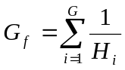
where G stands for the number of genes in the phylostratum, G_{f} is the number of founder genes in the phylostratum and 1 ≤ H ≤ G. The lowest value that G_{f} could obtain is one, denoting that all genes in the phylostratum are related, whereas the maximum value is G and denotes all genes in the phylostratum are founders. We estimated the rate of fixation of founder genes (G_{f} per MY) using the molecular clock time estimates from studies [10,11] which covered neighboring nodes around phylostratum 6. Time estimates for other nodes we compiled form several sources (Table S1).

Assignment of expression characteristics
We retrieved expression data for 4,141 genes obtained by in situ hybridizations in Drosophila embryos together with the annotations from the Berkeley Drosophila Genome Project [12] (Table 1 in the main article). Around 200 anatomical terms used for annotation of the expression events we labelled as ectoderm, endoderm or mesoderm derived, using DAG Editor and structured controlled vocabulary from FlyBase (http://flybase.net/data/docs/bodyparts-cv.txt).

Functional data
We used D. melanogaster functional annotation data from the biological process section of the Gene Ontology Database (http://www.geneontology.org) to compare the frequency of the annotated genes among phylostrata.

Statistics
Variation from the expected frequencies of expression events for the three germ layers (Figure 2a,b in the main text) was tested by a two-tailed hypergeometric test with Bonferroni correction (alpha = 0.025) using GeneMerge [13].

Table S1. Estimated fixation rates of founder genes

Phylostratum (internode) | Genes | Founder  Genes (G_{f}) | Peterson et al. 2004 [11] |  |  | Peterson et al. 2005 [10] |  |  | Douzery et al. 2004 [14]
 |  |  | Origin of the younger node (MYA) | Duration of the interval (MY) | Average Rate (Founder genes / MY) | Origin of the younger node (MYA) | Duration of the interval (MY) | Average Rate (Founder genes / MY) | Origin of the younger node (MYA) | Duration of the interval (MY) | Average Rate (Founder genes / MY)
(12) Diptera – D. melanogaster | 2356 | 1974.2 |  | 235 | 8.40 |  | 235 | 8.40 |  | 265 | 7.45
(11) Insecta –  Diptera | 467 | 359.3 | 235 | 90 | 3.99 | 235 | 90 | 3.99 | 265 [15] | 192 | 1.87
(10) Pancrustacea –Insecta | 417 | 223.5 | 325 | 196 | 1.14 | 325 | 196 | 1.14 | 354 | 163ª | 1.37ª
(9) Arthropoda – Pancrustacea | 78 | 41.6 | 521 [15] | 21 | 1.98 | 521 [15] | 25 | 1.66 | ? | 163ª | 1.37ª
(8) Protostomia – Arthropoda | 52 | 29.2 | 542 | 18 | 1.62 | 546 | 15 | 1.95 | 517 | 108 | 0.27
(7) Bilateria – Protostomia | 134 | 64.8 | 560 | 13 | 4.98 | 561 | 18 | 3.60 | 625 | 70 | 0.93
(6) Eumetazoa – Bilateria | 1058 | 736.4 | 573 | 42 | 17.53 | 579 | 25 | 29.46 | 695 | 154^{b} | 4.78^{b}
(5) Metazoa – Eumetazoa | 414 | 239.3 | 615 | 38 | 6.30 | 604 | 60 | 3.99 | ? | 154^{b} | 4.78^{b}
(4) Opisthokonta – Metazoa | 216 | 104.7 | 653 | 894 | 0.12 | 664 | 883 | 0.12 | 849^{c} | 135 | 0.78
(3) Eukaryota - Opisthokonta | 214 | 158.0 | 1547 [16] | 553 | 0.29 | 1547 [16] | 553 | 0.29 | 984 | 1116 | 0.14
(2) Cellular org. – Eukaryota | 3105 | 1559.5 | 2100 [17] | 1800 | 0.87 | 2100 [17] | 1800 | 0.87 | 2100 [17] | 1800 | 0.87
(1) Life before LCA of Cellular org. - Cellular org. | 4871 | 1319.3 | 3900 [18] |  |  | 3900 [18] |  |  | 3900 [18]
Total | 13382 | 6809.7
ªAveraged over the phylostrata 9 plus 10 (Arthropoda – Insecta interval).
^{b}Averaged over the phylostrata 5 plus 6 (Metazoa - Bilateria interval).
^{c}A time estimate for the LCA of choanoflagellates and bilaterians.
Table S2. Contents of the databases used in the BLAST sequence similarity searches
Node | NCBI nr database sequences | Genomes included in nr database | TRACE sequences | EST sequences
Drosophila | 48,945 | D. pseudoobscura  D. melanogaster
Diptera | 23,698 | Anopheles gambiae
Insecta | 39,419 | Apis mellifera (6355 proteins)
Pancrustacea | 5,515 | - | 2,724,768 WGS (Daphnia pulex) | 65,470 (15 Crustacea species)
Arthropoda | 5,855 | - | 8,106,820 WGS (Ixodes scapularis) | 41,900 (6 Arachnida species)
Protostomia | 73,297 | Caenorhabditis briggsae (Nematoda)  Caenorhabditis elegans (Nematoda)
Bilateria | 647,049 | Homo sapiens, Mus musculus, Bos taurus, Danio rerio, Canis canis, Rattus norvegicus, Tetraodon nigroviridis, Pan troglodytes, Gallus gallus, Strongylocentrotus purpuratus, Xenopus laevis
Eumetazoa | 1,919 | - | 5,996,730 WGS (Nematostella vectensis)  10,125,608 WGS  (Hydra magnipapillata) | 146,976 (Nematostella vectensis)  174,162 (Hydra magnipapillata)  22905 (9 Cnidaria species)
Metazoa | 727 | - | 1,787,987 WGS (Reniera sp.) | 83,040 (Reniera sp.)
Opisthokonta | 148,449 | ~15 fungal genomes
Eukaryota | 366,351 | ~ 11 eukaryotic genomes (2 higher plants)
Cellular org. | 1,416,631 | ~ 27 archeal genomes  ~337 bacterial genomes
Total | 2,777,855

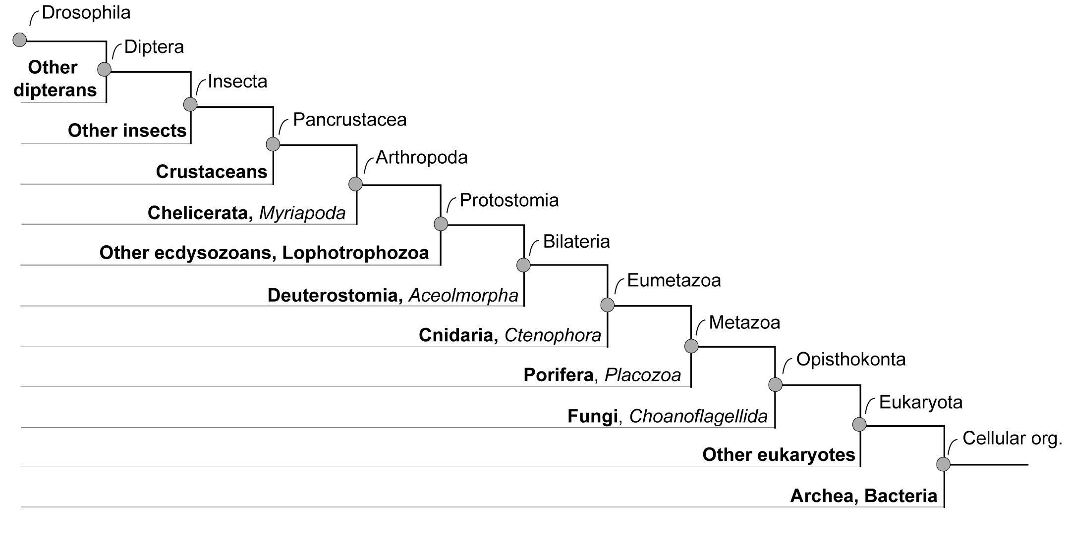
Figure S1. Phylogenetic framework used in the search for the gene origins. Taxa represented in the databases with complete genomes or a substantial amount of TRACE and EST data are in bold. Taxa in italics are represented in the databases only with small numbers of highly conserved genes and their exclusion from the analysis does not influence the results.

Extended glossary
Neofunctionalization: gain of a novel functional property of a duplicate copy after the gene duplication event.
Orphan genes (orphans): protein-coding genes that have no recognizable homolog in distantly related species.
Radical neofunctionalization: a type of neofunctionalization which results in the complete loss of sequence similarity to other genes in the genome.
Subfunctionalization: split of ancestral gene functions between duplicate copies after the gene duplication event - usually in the context of expression characteristics.

References
1 Altenberg, L. (1995) Genome growth and the evolution of the genotype-phenotype map. In Evolution and Biocomputation: Computational Models of Evolution, LNCS (Vol. 899) (Banzhaf, W. and Eeckman, F.H., eds), pp. 205–259 Springer Verlag
2 Domazet-Lošo, T. and Tautz, D. (2003) An evolutionary analysis of orphan genes in Drosophila. Genome Res. 13, 2213–2219
3 Long, M. et al. (2003) The origin of new genes: glimpses from the young and old. Nat. Rev. Genet. 4, 865–875
4 Choi, I.G. and Kim, S.H. (2006) Evolution of protein structural classes and protein sequence families. Proc. Natl. Acad. Sci. U. S. A. 103, 14056–14061
5 Force, A. et al. (1999) Preservation of duplicate genes by complementary, degenerative mutations. Genetics 151, 1531–1545
6 Thornton, J.W. (2005) New genes, new functions: gene family evolution and phylogenetics. In Evolutionary Genetics: Concepts and Case Studies (Fox, C. and Wolf J., eds), pp. 157–172, Oxford University Press
7 Prince, V.E. and Pickett, F.B. (2002) Splitting pairs: The diverging fates of duplicated genes. Nat. Rev. Genet. 3, 827–837
8 Lynch, M. and Conery, J.S. (2000) The evolutionary fate and consequences of duplicate genes. Science 290, 1151–1155
9 Oakley, T.H. et al. (2006) Repression and loss of gene expression outpaces activation and gain in recently duplicated fly genes. Proc. Natl. Acad. Sci. U. S. A. 103, 11637–11641
10 Peterson, K.J. and Butterfield, N.J. (2005) Origin of the Eumetazoa: Testing ecological predictions of molecular clocks against the Proterozoic fossil record. Proc. Natl. Acad. Sci. U. S. A. 102, 9547–9552
11 Peterson, K.J. et al. (2004) Estimating metazoan divergence times with a molecular clock. Proc. Natl. Acad. Sci. U. S. A. 101, 6536–6541
12 Tomancak, P. et al. (2002) Systematic determination of patterns of gene expression during Drosophila embryogenesis. Genome Biol. 3, research0088.1–0088.14
13 Castillo-Davis, C.I. and Hartl, D.L. (2003) GeneMerge–post-genomic analysis, data mining, and hypothesis testing. Bioinformatics 19, 891–892
14 Douzery, E.J.P. et al. (2004) The timing of eukaryotic evolution: Does a relaxed molecular clock reconcile proteins and fossils? Proc. Natl. Acad. Sci. U. S. A. 101, 15386–15391
15 Gaunt, M.W. and Miles, M.A. (2002) An insect molecular clock dates the origin of the insects and accords with palaeontological and biogeographic landmarks. Mol. Biol. Evol. 19, 748–761
16 Hedges, S.B. et al. (2004) A molecular timescale of eukaryote evolution and the rise of complex multicellular life. BMC Evol. Biol. 4, 2
17 Embley, T.M. and Martin, W. (2006) Eukaryotic evolution, changes and challenges. Nature 440, 623–630
18 Schopf, J.W. et al. (2002) Laser-Raman imagery of Earth's earliest fossils. Nature 416, 73–76

